A000-ME-Pergamon-Dying Gaul-Marble-ca 225 BCE

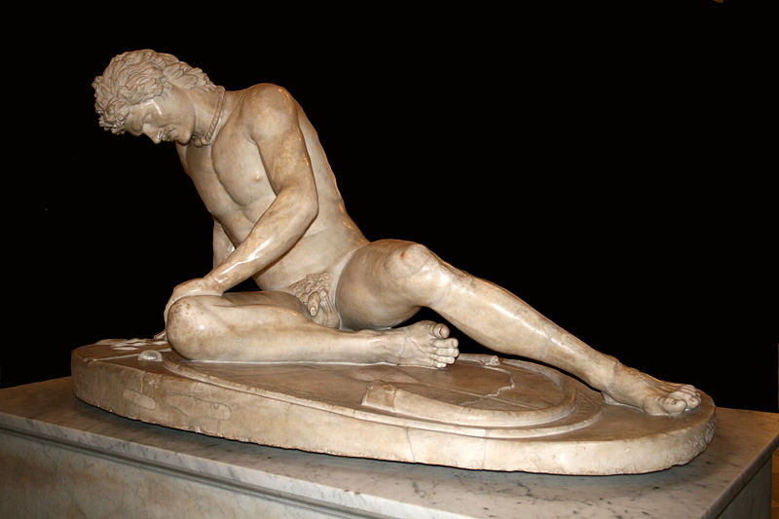

ME-Pergamon-Dying Gaul-Marble-ca 225 BCE

**Case no.: 4**

**Accession Number:**

**Formal Label: Formal Label:** ME-Pergamon-Dyling Gaul-Marble-ca 225 BCE

**Display Description:**

The statue called either the dying Gaul or the dying Galatian now in the Capitoline Museums, Rome, was commissioned by Attalus I of Pergamon (269–197 BCE) to memorialize the Celts' defeat (ca 230-220 BCE) by the forces of Pergamon, an Ionian Greek polis that had sought to stem the raiding of the Celts of Trace in Anatolia. In 278 BCE, migrating Celtic tribes from Gaul had crossed the Hellespont and settled in Galatia to the east. In a series of campaigns fought some fifty years later, they were defeated by Attalus I in defense of the Greek cities of the region. The statue likely is a second-century CE Roman copy of a third-century BCE Hellenistic bronze commemorating that victory. This statue thus memorialized the power and bravery of the Pergamonians and corroborates ancient accounts of the Galatian Celtic fighting style in the nude as Diodorus Siculus reported: "Some of them have iron breastplates or chainmail while others fight naked (Alllen 2001: 22). Polybius wrote an evocative account of Galatian tactics against a Roman army at the Battle of Telamon of 225 BCE:

"The Insubres and the Boii wore trousers and light cloaks, but the Gaesatae, in their love of glory and defiant spirit, had thrown off their garments and taken up their position in front of the whole army naked and wearing nothing but their arms... The appearance of these naked warriors was a terrifying spectacle, for they were all men of splendid physique and in the prime of life" [(](https://en.wikipedia.org/wiki/Dying_Gaul#cite_note-6)Polybius, *Histories* II.28).

The Roman historian Livy recorded that the Celts of Anatoia fought naked and their wounds were plain to see on the whiteness of their bodies (Livy, *History* XXII.46 and XXXVIII.21).  The Greek historian Dionysius of Halicarnassus regarded this as a foolish tactic: "Our enemies fight naked. What injury could their long hair, their fierce looks, their clashing arms do us? These are mere symbols of barbarian boastfulness” (Dionysius of Halicarnassus, History of Rome XIV.9).

Epigonus (fl 230-220 BCE), a court sculptor of the [Attalid dynasty](https://en.wikipedia.org/wiki/Attalid_dynasty" \o "Attalid dynasty) of Pergamon, may have been commissioned by [Attalus I](https://en.wikipedia.org/wiki/Attalus_I) to design and execute the work.

**LC Classification:**

**Date or Time Horizon:**

**Geographical Area:**

**Map:**

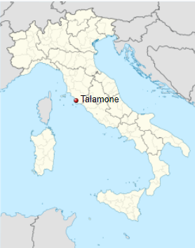

**GPS coordinates:** [42.555056°N 11.132755°E](https://tools.wmflabs.org/geohack/geohack.php?pagename=Talamone&params=42.555056_N_11.132755_E_type:city_region:IT-52)

**Cultural Affiliation:** Pergamon

**Medium:** original bronze, Roman copy marble

**Dimensions:**

**Weight:**

**Condition: Miniature copy of Roman marble copy**

**Provenance:**

**Discussion:**

The Roman historian Livy recorded that the Celts of Anatoia fought naked and their wounds were plain to see on the whiteness of their bodies (Livy, *History* XXII.46 and XXXVIII.21).  The Greek historian Dionysius of Halicarnassus regarded this as a foolish tactic: "Our enemies fight naked. What injury could their long hair, their fierce looks, their clashing arms do us? These are mere symbols of barbarian boastfulness” (Dionysius of Halicarnassus, History of Rome XIV.9).

Epigonus (fl 230-220 BCE), a court sculptor of the Attalid dynasty of Pergamon, may have been commissioned by Attalus I to design and execute the work.

**References:**

***The Dying Gaul***, also called ***The Dying Galatian***[[1]](https://en.wikipedia.org/wiki/Dying_Gaul#cite_note-Capitoline_Museums-1) (in [Italian](https://en.wikipedia.org/wiki/Italian_language): *Galata Morente*) or ***The Dying Gladiator***, is an [Ancient Roman](https://en.wikipedia.org/wiki/Roman_art) [marble](https://en.wikipedia.org/wiki/Marble) copy of a lost [Hellenistic](https://en.wikipedia.org/wiki/Hellenistic) sculpture, thought to have been originally executed in [bronze](https://en.wikipedia.org/wiki/Bronze_sculpture).[[2]](https://en.wikipedia.org/wiki/Dying_Gaul#cite_note-2) The original may have been commissioned some time between 230 and 220 BC by [Attalus I](https://en.wikipedia.org/wiki/Attalus_I) of [Pergamon](https://en.wikipedia.org/wiki/Pergamon) to celebrate his victory over the [Galatians](https://en.wikipedia.org/wiki/Galatians_(People)), the [Celtic](https://en.wikipedia.org/wiki/Celts) or [Gaulish](https://en.wikipedia.org/wiki/Gaul" \o "Gaul)people of parts of [Anatolia](https://en.wikipedia.org/wiki/Anatolia) (modern [Turkey](https://en.wikipedia.org/wiki/Turkey)). The identity of the sculptor of the original is unknown, but it has been suggested that [Epigonus](https://en.wikipedia.org/wiki/Epigonus" \o "Epigonus), a court sculptor of the [Attalid dynasty](https://en.wikipedia.org/wiki/Attalid_dynasty" \o "Attalid dynasty) of Pergamon, may have been the creator.

The copy was most commonly known as *The Dying Gladiator* until the 20th century on the assumption that it depicted a wounded gladiator in a Roman amphitheatre.[[3]](https://en.wikipedia.org/wiki/Dying_Gaul#cite_note-3) Scholars had identified it as a Gaul or Galatian by the mid-19th century, but it took many decades for the new title to achieve popular acceptance.

Diodorus in Stephen Allen (Author), Wayne Reynolds (Illustrator), *Celtic Warrior: 300 BCE – 100 CE* (Osprey: 25 April 2001),